|  |
| --- |
|  |
| Capstone Project Document |

**First Aid**

Report #2 – Class Design

|  |  |  |
| --- | --- | --- |
| **First Aid** | | |
| **Group Members** | Đàm Huy Hùng | SE03431 |
| Nguyễn Duy Anh | 01525 |
| Mai Trung Kiên | SE02994 |
| Nguyễn Tiến Dũng | SE03272 |
| Nguyễn Phúc An | SE03118 |
| **Supervisor** | Mr. Nguyễn Văn Sang | |
| **Project code** | FAVN | |

**- Hanoi, 09/2016 -**

# SIGNATURE PAGE

AUTHOR: Đàm Huy Hùng 10/10/2016

Project Manager

REVIEWERS: Mai Trung Kiên 30/09/2016

Team member

APPROVAL: Nguyễn Văn Sang --/--/--16

Supervisor

Record of change

*A - Added M - Modified D – Deleted

|  |  |  |  |  |  |
| --- | --- | --- | --- | --- | --- |
| Effective Date | Changed Item | A,M,D | Change Description | Reason for Change | Rev. Number |
|  |  |  |  |  |  |
|  |  |  |  |  |  |
|  |  |  |  |  |  |

TABLE CONTENTS

SIGNATURE PAGE 1

Introduction 3

1.1 Purpose 3

1.2 Definitions, Acronyms and Abbreviations 3

2 Package 3

2.1 Package Diagram 3

2.2 Package Description 4

2.2.1 Model 4

2.2.2 DTOs 10

2.2.3 View 10

2.2.4 Repository 11

2.2.5 Controller 14

3 Function 25

3.1 Common 25

3.1.1 Class diagram 25

3.1.2 Sequence diagram 25

3.2 Project management 28

3.2.1 Class diagram 28

3.2.2 Sequence diagram 29

3.3 Comment 39

3.3.1 Class diagram 39

3.3.2 Sequence diagram 39

3.4 Message 41

3.4.1 Class diagram 41

3.4.2 Sequence diagram 42

3.5 User Management 43

3.5.1 Class diagram 43

3.5.2 Sequence diagram 44

3.6 Report Management 45

3.6.1 Class diagram 45

3.6.2 Sequence diagram 46

3.7 Manage Slide 48

3.7.1 Class diagram 48

3.7.2 Sequence diagram 48

3.8 Manage Category 51

3.8.1 Class diagram 51

3.8.2 Sequence diagram 52

# 1 Introduction

## Purpose

Dandelion class design document contains descriptions of all classes of the Dandelion. It includes: Class diagrams that describe the static relation of all classes in the system.

## Definitions, Acronyms and Abbreviations

|  |  |  |
| --- | --- | --- |
| Abbreviations | Description | Comment |
| FAVN | First Aid Vietnam |  |
| FAA | First Aid Application |  |
| FAQ | Frequently Asked Question |  |

Table -1: Definitions, Acronyms and Abbreviations

# Package

## Package Diagram

### First Aid Application

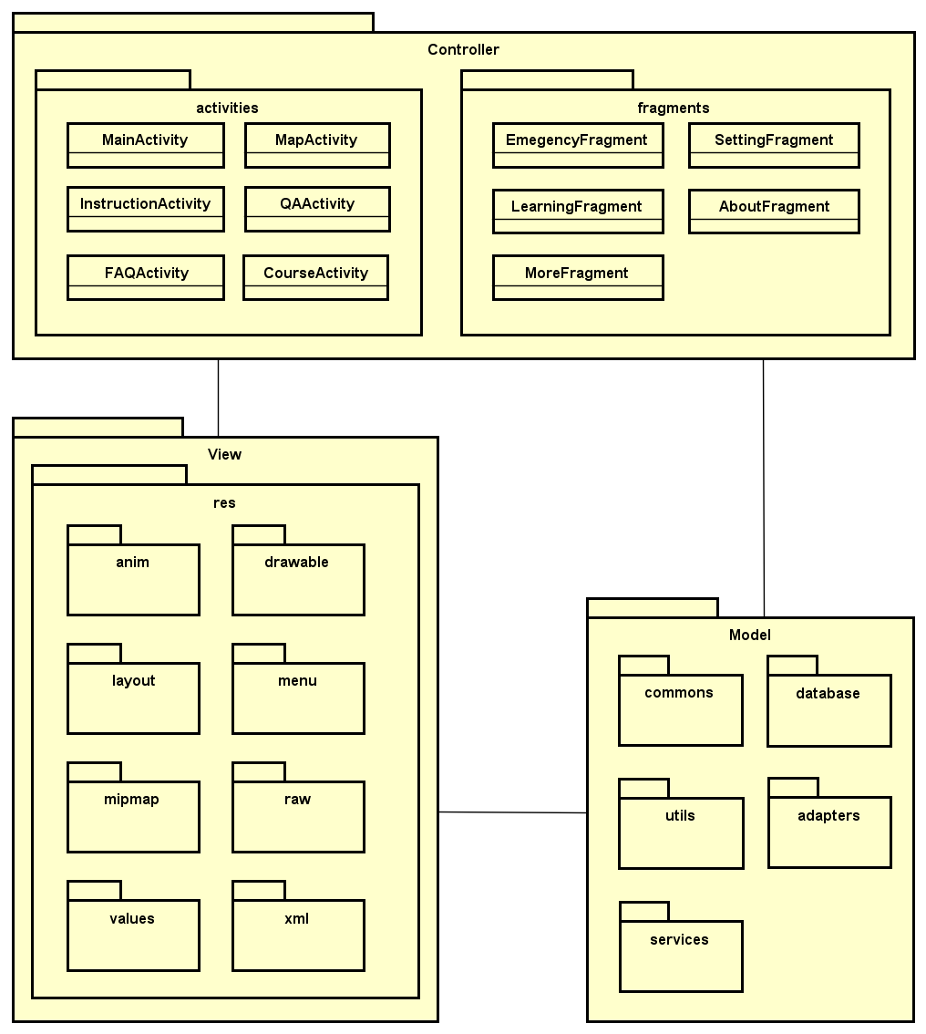

1. FAA Package Diagram

### Ambulance Application

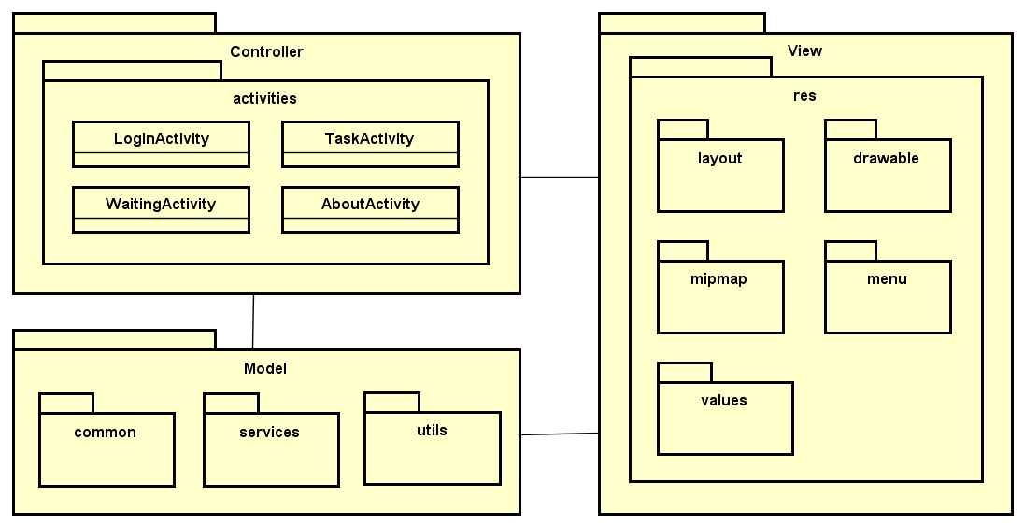

1. Ambulance Application Package Diagram

### Dispatcher Application

### Admin/Expert Application

## Package Description

### First Aid Application

#### Controller

##### Activities

###### MainActivity

|  |  |  |  |  |  |
| --- | --- | --- | --- | --- | --- |
| **No** | **Field Name** | **Type** | **Default** | **Note** | **Description** |
|  | UserID | int |  | private | User’s ID |
|  | UserName | String |  | private | User’s name |
|  | Password | String |  | private | User’s password |
|  | IsActive | bool | false | private | User’s active status (inactive, active) |
|  | CreatedDate | Datetime |  | private | User’s created date |
|  | LoginType | String | normal | private | User’s created type includes: normal, Facebook or both |
|  | LastLogin | Datetime |  | private | User’s last login |
|  | UserType | String | normal | private | User’s type (admin or nomal user) |
|  | IsVerify | bool | false | private | User’ email verify status |

1. DDL_User model

###### MapActivity

|  |  |  |  |  |  |
| --- | --- | --- | --- | --- | --- |
| **No** | **Field Name** | **Type** | **Default** | **Note** | **Description** |
|  | UserID | int |  | private | User’s ID |
|  | UserName | String |  | private | User’s name |
|  | Password | String |  | private | User’s password |
|  | IsActive | bool | false | private | User’s active status (inactive, active) |
|  | CreatedDate | Datetime |  | private | User’s created date |
|  | LoginType | String | normal | private | User’s created type includes: normal, Facebook or both |
|  | LastLogin | Datetime |  | private | User’s last login |
|  | UserType | String | normal | private | User’s type (admin or nomal user) |
|  | IsVerify | bool | false | private | User’ email verify status |

1. DDL_User model

###### InstructionActivity

|  |  |  |  |  |  |
| --- | --- | --- | --- | --- | --- |
| **No** | **Field Name** | **Type** | **Default** | **Note** | **Description** |
|  | UserID | int |  | private | User’s ID |
|  | UserName | String |  | private | User’s name |
|  | Password | String |  | private | User’s password |
|  | IsActive | bool | false | private | User’s active status (inactive, active) |
|  | CreatedDate | Datetime |  | private | User’s created date |
|  | LoginType | String | normal | private | User’s created type includes: normal, Facebook or both |
|  | LastLogin | Datetime |  | private | User’s last login |
|  | UserType | String | normal | private | User’s type (admin or nomal user) |
|  | IsVerify | bool | false | private | User’ email verify status |

1. DDL_User model

###### QAActivity

|  |  |  |  |  |  |
| --- | --- | --- | --- | --- | --- |
| **No** | **Field Name** | **Type** | **Default** | **Note** | **Description** |
|  | UserID | int |  | private | User’s ID |
|  | UserName | String |  | private | User’s name |
|  | Password | String |  | private | User’s password |
|  | IsActive | bool | false | private | User’s active status (inactive, active) |
|  | CreatedDate | Datetime |  | private | User’s created date |
|  | LoginType | String | normal | private | User’s created type includes: normal, Facebook or both |
|  | LastLogin | Datetime |  | private | User’s last login |
|  | UserType | String | normal | private | User’s type (admin or nomal user) |
|  | IsVerify | bool | false | private | User’ email verify status |

1. DDL_User model

###### FAQActivity

|  |  |  |  |  |  |
| --- | --- | --- | --- | --- | --- |
| **No** | **Field Name** | **Type** | **Default** | **Note** | **Description** |
|  | UserID | int |  | private | User’s ID |
|  | UserName | String |  | private | User’s name |
|  | Password | String |  | private | User’s password |
|  | IsActive | bool | false | private | User’s active status (inactive, active) |
|  | CreatedDate | Datetime |  | private | User’s created date |
|  | LoginType | String | normal | private | User’s created type includes: normal, Facebook or both |
|  | LastLogin | Datetime |  | private | User’s last login |
|  | UserType | String | normal | private | User’s type (admin or nomal user) |
|  | IsVerify | bool | false | private | User’ email verify status |

1. DDL_User model

###### CourseActivity

|  |  |  |  |  |  |
| --- | --- | --- | --- | --- | --- |
| **No** | **Field Name** | **Type** | **Default** | **Note** | **Description** |
|  | UserID | int |  | private | User’s ID |
|  | UserName | String |  | private | User’s name |
|  | Password | String |  | private | User’s password |
|  | IsActive | bool | false | private | User’s active status (inactive, active) |
|  | CreatedDate | Datetime |  | private | User’s created date |
|  | LoginType | String | normal | private | User’s created type includes: normal, Facebook or both |
|  | LastLogin | Datetime |  | private | User’s last login |
|  | UserType | String | normal | private | User’s type (admin or nomal user) |
|  | IsVerify | bool | false | private | User’ email verify status |

1. DDL_User model

##### Fragment

###### EmegencyFragment

|  |  |  |  |  |  |
| --- | --- | --- | --- | --- | --- |
| **No** | **Field Name** | **Type** | **Default** | **Note** | **Description** |
|  | UserID | int |  | private | User’s ID |
|  | UserName | String |  | private | User’s name |
|  | Password | String |  | private | User’s password |
|  | IsActive | bool | false | private | User’s active status (inactive, active) |
|  | CreatedDate | Datetime |  | private | User’s created date |
|  | LoginType | String | normal | private | User’s created type includes: normal, Facebook or both |
|  | LastLogin | Datetime |  | private | User’s last login |
|  | UserType | String | normal | private | User’s type (admin or nomal user) |
|  | IsVerify | bool | false | private | User’ email verify status |

1. DDL_User model

###### SettingFragment

|  |  |  |  |  |  |
| --- | --- | --- | --- | --- | --- |
| **No** | **Field Name** | **Type** | **Default** | **Note** | **Description** |
|  | UserID | int |  | private | User’s ID |
|  | UserName | String |  | private | User’s name |
|  | Password | String |  | private | User’s password |
|  | IsActive | bool | false | private | User’s active status (inactive, active) |
|  | CreatedDate | Datetime |  | private | User’s created date |
|  | LoginType | String | normal | private | User’s created type includes: normal, Facebook or both |
|  | LastLogin | Datetime |  | private | User’s last login |
|  | UserType | String | normal | private | User’s type (admin or nomal user) |
|  | IsVerify | bool | false | private | User’ email verify status |

1. DDL_User model

###### LearningFragment

|  |  |  |  |  |  |
| --- | --- | --- | --- | --- | --- |
| **No** | **Field Name** | **Type** | **Default** | **Note** | **Description** |
|  | UserID | int |  | private | User’s ID |
|  | UserName | String |  | private | User’s name |
|  | Password | String |  | private | User’s password |
|  | IsActive | bool | false | private | User’s active status (inactive, active) |
|  | CreatedDate | Datetime |  | private | User’s created date |
|  | LoginType | String | normal | private | User’s created type includes: normal, Facebook or both |
|  | LastLogin | Datetime |  | private | User’s last login |
|  | UserType | String | normal | private | User’s type (admin or nomal user) |
|  | IsVerify | bool | false | private | User’ email verify status |

1. DDL_User model

###### AboutFragment

|  |  |  |  |  |  |
| --- | --- | --- | --- | --- | --- |
| **No** | **Field Name** | **Type** | **Default** | **Note** | **Description** |
|  | UserID | int |  | private | User’s ID |
|  | UserName | String |  | private | User’s name |
|  | Password | String |  | private | User’s password |
|  | IsActive | bool | false | private | User’s active status (inactive, active) |
|  | CreatedDate | Datetime |  | private | User’s created date |
|  | LoginType | String | normal | private | User’s created type includes: normal, Facebook or both |
|  | LastLogin | Datetime |  | private | User’s last login |
|  | UserType | String | normal | private | User’s type (admin or nomal user) |
|  | IsVerify | bool | false | private | User’ email verify status |

1. DDL_User model

###### MoreFragment

|  |  |  |  |  |  |
| --- | --- | --- | --- | --- | --- |
| **No** | **Field Name** | **Type** | **Default** | **Note** | **Description** |
|  | UserID | int |  | private | User’s ID |
|  | UserName | String |  | private | User’s name |
|  | Password | String |  | private | User’s password |
|  | IsActive | bool | false | private | User’s active status (inactive, active) |
|  | CreatedDate | Datetime |  | private | User’s created date |
|  | LoginType | String | normal | private | User’s created type includes: normal, Facebook or both |
|  | LastLogin | Datetime |  | private | User’s last login |
|  | UserType | String | normal | private | User’s type (admin or nomal user) |
|  | IsVerify | bool | false | private | User’ email verify status |

1. DDL_User model

#### Model

##### commons

###### Caller

###### CallerInforSender

###### Distance

###### Faq

###### HealthFaility

###### InformationSenderListener

###### Injury

###### Instruction

###### Question

###### QuestionSender

##### database

###### DatabaseOpenHelper

##### utils

###### Connector

###### Constants

###### NetworkStatus

###### SettingPref

###### Sort

###### SOSCalling

###### StringConverter

##### adapters

###### FaqAdapter

###### HealthFacilityAdapter

###### HealthFacilityFilter

###### InjuryAdapter

###### InstructionAdapter

###### ItemsListAdapter

##### services

###### direction

Direction

DirectionFinder

###### distanceMatrix

DistanceMatrix

DistanceMatrixFinder

###### location

LocationFinder

###### FetchAddressIntentService

#### View

### Ambulance Application

#### Controller

##### activities

###### AboutActivity

###### LoginActivity

###### TaskActivity

###### WaitingActivity

#### Model

##### commons

###### Ambulance

###### AmbulanceInfoSender

###### User

###### UserSender

##### services

###### ditection

Direction

DirectionFinder

###### location

LocationFinder

##### utils

###### SharedPreferencesData

#### View

### Dispatcher Application

### Admin/Expert Application

# Function

## First Aid Application

### Emergencies

#### Class diagram

#### Sequence diagram

##### View list of injuries

##### View instruction steps of injury

##### Search injuries

##### Call 115

##### Speak instruction steps

##### View current location

##### View nearest list of health facilities

##### Show direction to health facility

##### Call to health facility

### Learning

#### Class diagram

#### Sequence diagram

##### View list of learning injuries

##### View learning instruction steps

##### View FAQs

### More

#### Class diagram

#### Sequence diagram

##### Send questions

##### View courses

##### Share application

### Setting

#### Class diagram

#### Sequence diagram

##### Allow to show advice tips

##### Allow to send information

### Info

#### Class diagram

#### Sequence diagram

##### View application information

## Ambulance Application

### Common

#### Login

#### Logout

### Emergency

#### View ambulance team information

#### Accept/Decline task

#### Show the location of caller

#### Show direction to caller

#### Report picked up caller

#### Report completed task

#### Report problem

#### Change status

## Dispatcher Application

### Common

#### Login

#### Logout

### Dispatch

#### Create emergency case

#### Dispatch an ambulance

#### View ambulance information

#### View caller information

#### Show direction from ambulance to caller

#### View list of callers

#### Notify ambulances status

#### Cancel emergency case

## Admin/Expert Application

### Admin

#### Common

##### Login

##### Logout

#### Manage user’s account

##### Create account

##### View list user

##### Search user’s account

##### Update user’s account

##### Delete user’s account

#### Manage Q&A

##### View user’s question

##### View answer

##### Answer question

### Expert

#### Common

##### Login

##### Logout

#### Manage Q&A

##### View user’s question

##### View answer

##### Answer the question

#### Manage injury

##### Add new injury

##### Search injury

##### Update injury

##### Dalete injury